**Project Design Phase-II Technology Stack (Architecture & Stack)**

|  |  |
| --- | --- |
| Date | 09 November 2022 |
| Team ID | PNT2022TMID26125 |
| Project Name | Inventory Management System for Retailers |
| Maximum Marks | 4 Marks |

**Technical Architecture:**

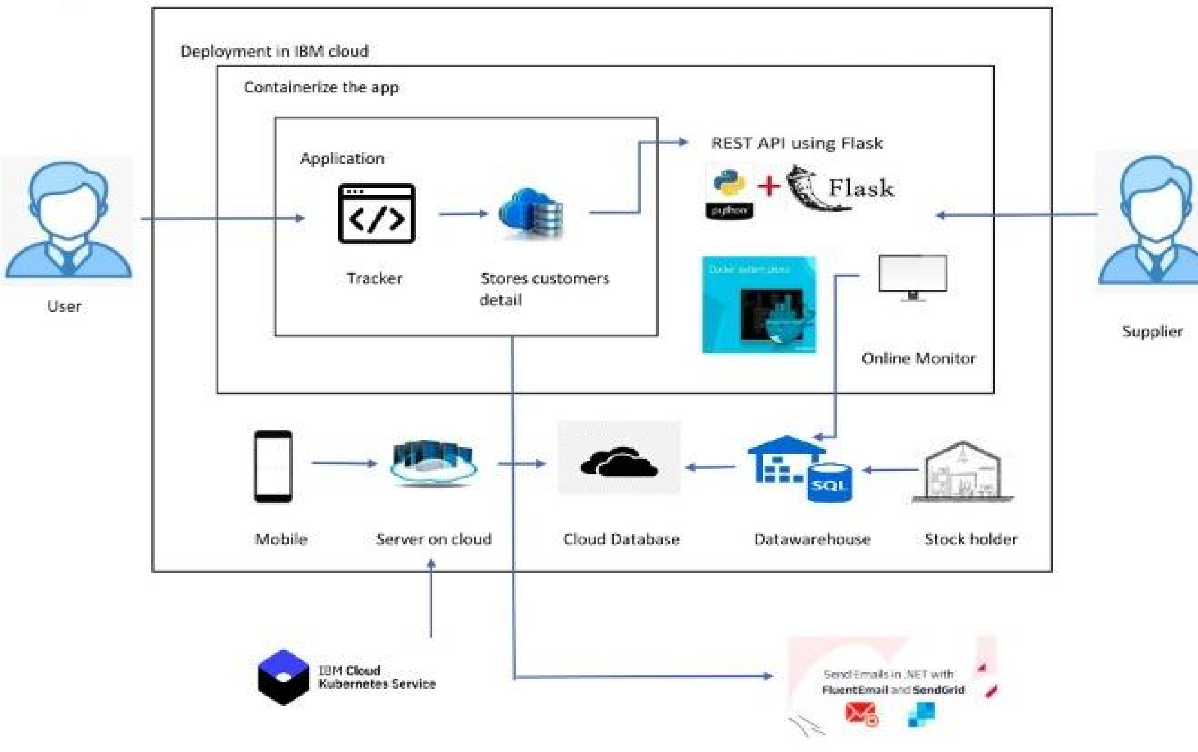

**Table-1: Components & Technologies:**

|  |  |  |  |
| --- | --- | --- | --- |
| **S. No** | **Component** | **Description** | **Technology** |
| 1. | User Interface | Web UI | HTML, CSS, JavaScript |
| 2. | Application Logic | Logic for a process in the application | Python Flask |
| 3. | Database | Data Type, Configurations etc. | DB2 |
| 4. | Cloud Database | Database Service on Cloud | IBM DB2 |
| 5. | File Storage | File storage requirements | IBM Object Storage |
| 6. | Indication | Receive an indication when an item trying to buy is too much than the stock available. | SendGrid |
| 7. | Infrastructure (Server / Cloud) | Application Deployment on Local System / Cloud Local Server Configuration:  Cloud Server Configuration: | Local, Cloud Foundry, Kubernetes, etc. |
| 8. | Location | Can be able to see items from a particular store location | Python Flask |

**Table-2: Application Characteristics:**

|  |  |  |  |
| --- | --- | --- | --- |
| **S. No** | **Characteristics** | **Description** | **Technology** |
| 1. | Open-Source Frameworks | The technologies listed are used for open-source | HTML, CSS, JS, Python Flask |
| 2. | Security Implementations | User login and authorization are done to implement the security access. | IBM cloud security |
| 3. | Scalable Architecture | The architecture is possible because of virtualization | Docker, Kubernetes |
| 4. | Availability | The system availability is made sure | IBM DB2 |
| 5. | Performance | The access and response time is much faster. | Python Flask, Docker, DB2 |